Solid Geometry - Solid of Revolution - According to Geometric Shape - Conical Solids of Revolution

Definition
# Source: AI Source: Provided by: [Data Path: Persons Table -> ID Column: 1, Name_En Column: Motasem Essam] -> From: [ChatGPT] on [7/25/2026]
Conical Solids of Revolution are three-dimensional solids generated by rotating triangular or trapezoidal plane regions around a suitable straight axis in their plane.
The rotation produces solids with circular bases and one or more conical surfaces. Their defining geometric characteristic is that their radius changes along the axis, generally tapering toward a vertex or changing between two circular bases.
The principal examples are:
- Right Circular Cone.
- Conical Frustum.
- Double Cone.
- Hollow Conical Solid.
A right circular cone is generated by rotating a right-triangular region around one of its perpendicular sides.

Geometric Representation
# Source: AI Source: Provided by: [Data Path: Persons Table -> ID Column: 1, Name_En Column: Motasem Essam] -> From: [ChatGPT] on [7/25/2026]
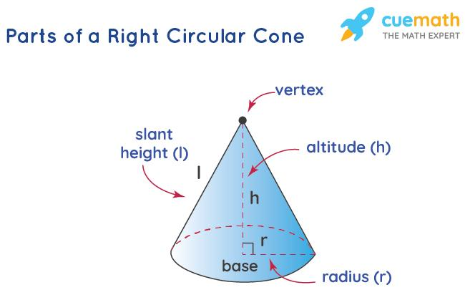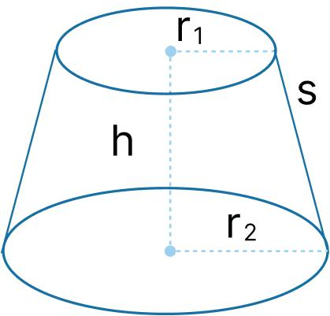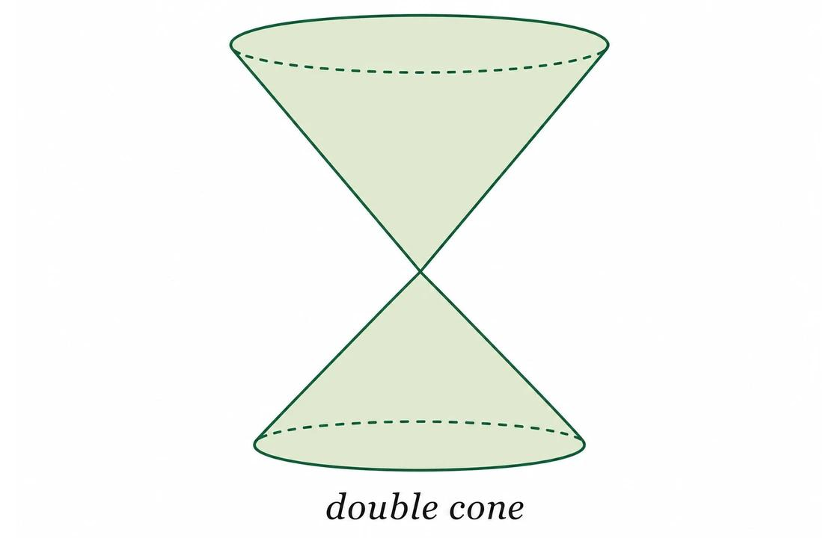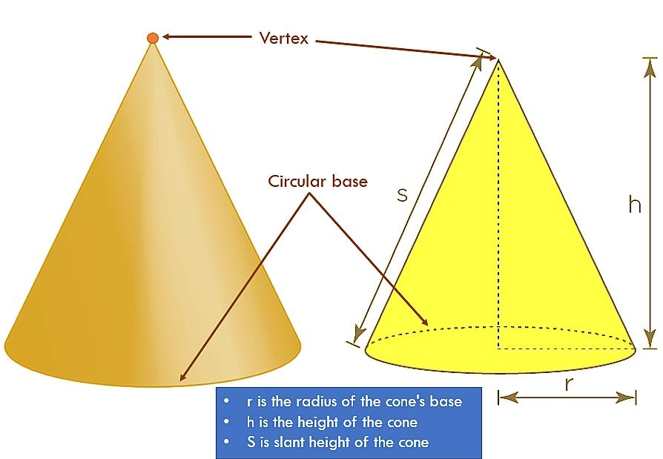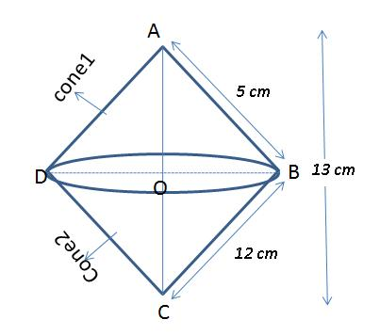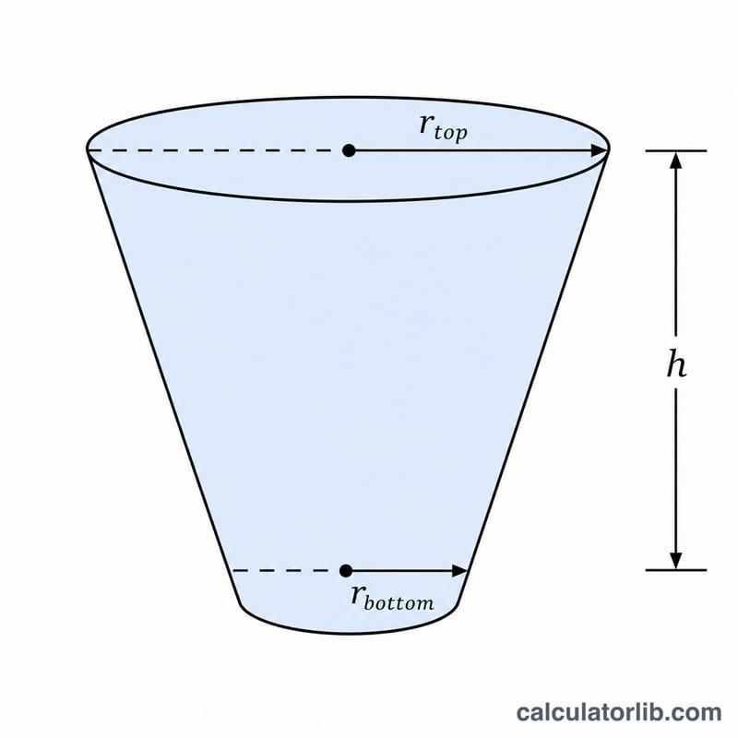
The generating region determines the resulting conical solid:
- A right-triangular region rotated around one of its legs generates a right circular cone.
- A right-trapezoidal region rotated around its perpendicular leg generates a conical frustum.
- A triangular region rotated around its altitude can generate a double cone.
- A region positioned away from an external axis can generate a hollow conical solid.

Geometric Structure
# Source: AI Source: Provided by: [Data Path: Persons Table -> ID Column: 1, Name_En Column: Motasem Essam] -> From: [ChatGPT] on [7/25/2026]
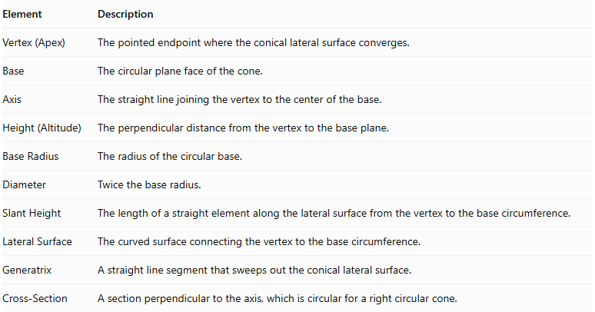
Element | Description
Vertex (Apex) | The pointed endpoint where the conical lateral surface converges.
Base | The circular plane face of the cone.
Axis | The straight line joining the vertex to the center of the base.
Height (Altitude) | The perpendicular distance from the vertex to the base plane.
Base Radius | The radius of the circular base.
Diameter | Twice the base radius.
Slant Height | The length of a straight element along the lateral surface from the vertex to the base circumference.
Lateral Surface | The curved surface connecting the vertex to the base circumference.
Generatrix | A straight line segment that sweeps out the conical lateral surface.
Cross-Section | A section perpendicular to the axis, which is circular for a right circular cone.

Types of Conical Solids of Revolution

Right Circular Cone
# Source: AI Source: Provided by: [Data Path: Persons Table -> ID Column: 1, Name_En Column: Motasem Essam] -> From: [ChatGPT] on [7/25/2026]
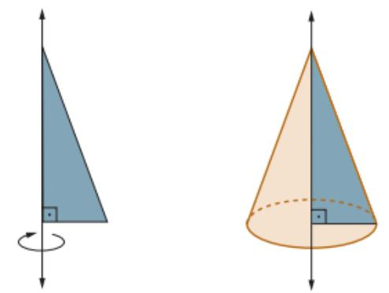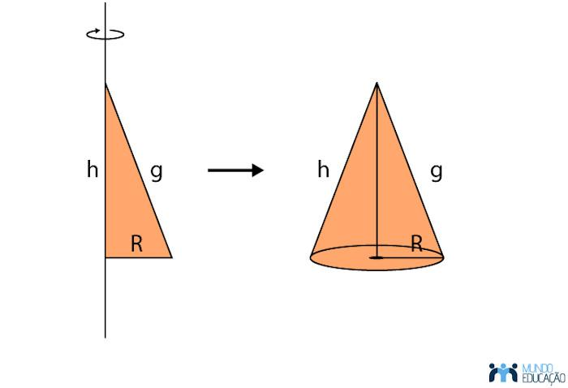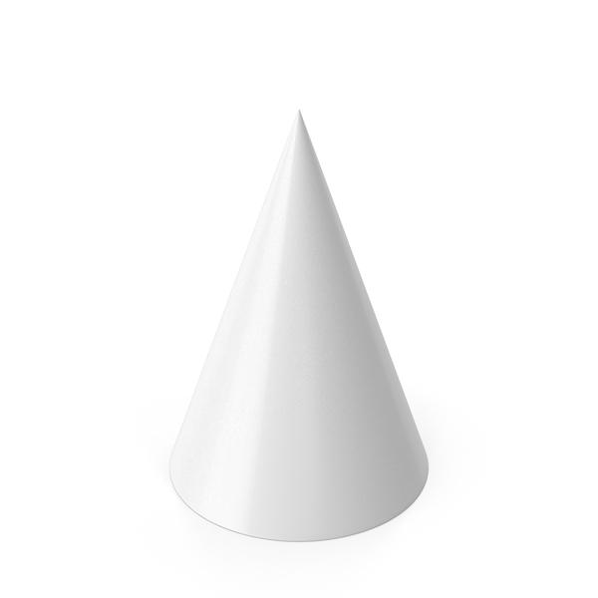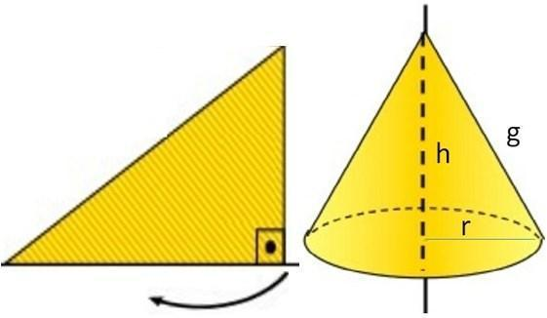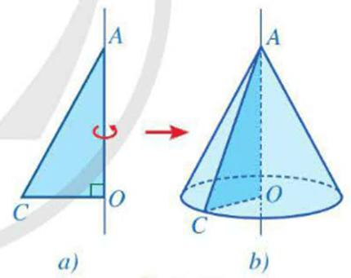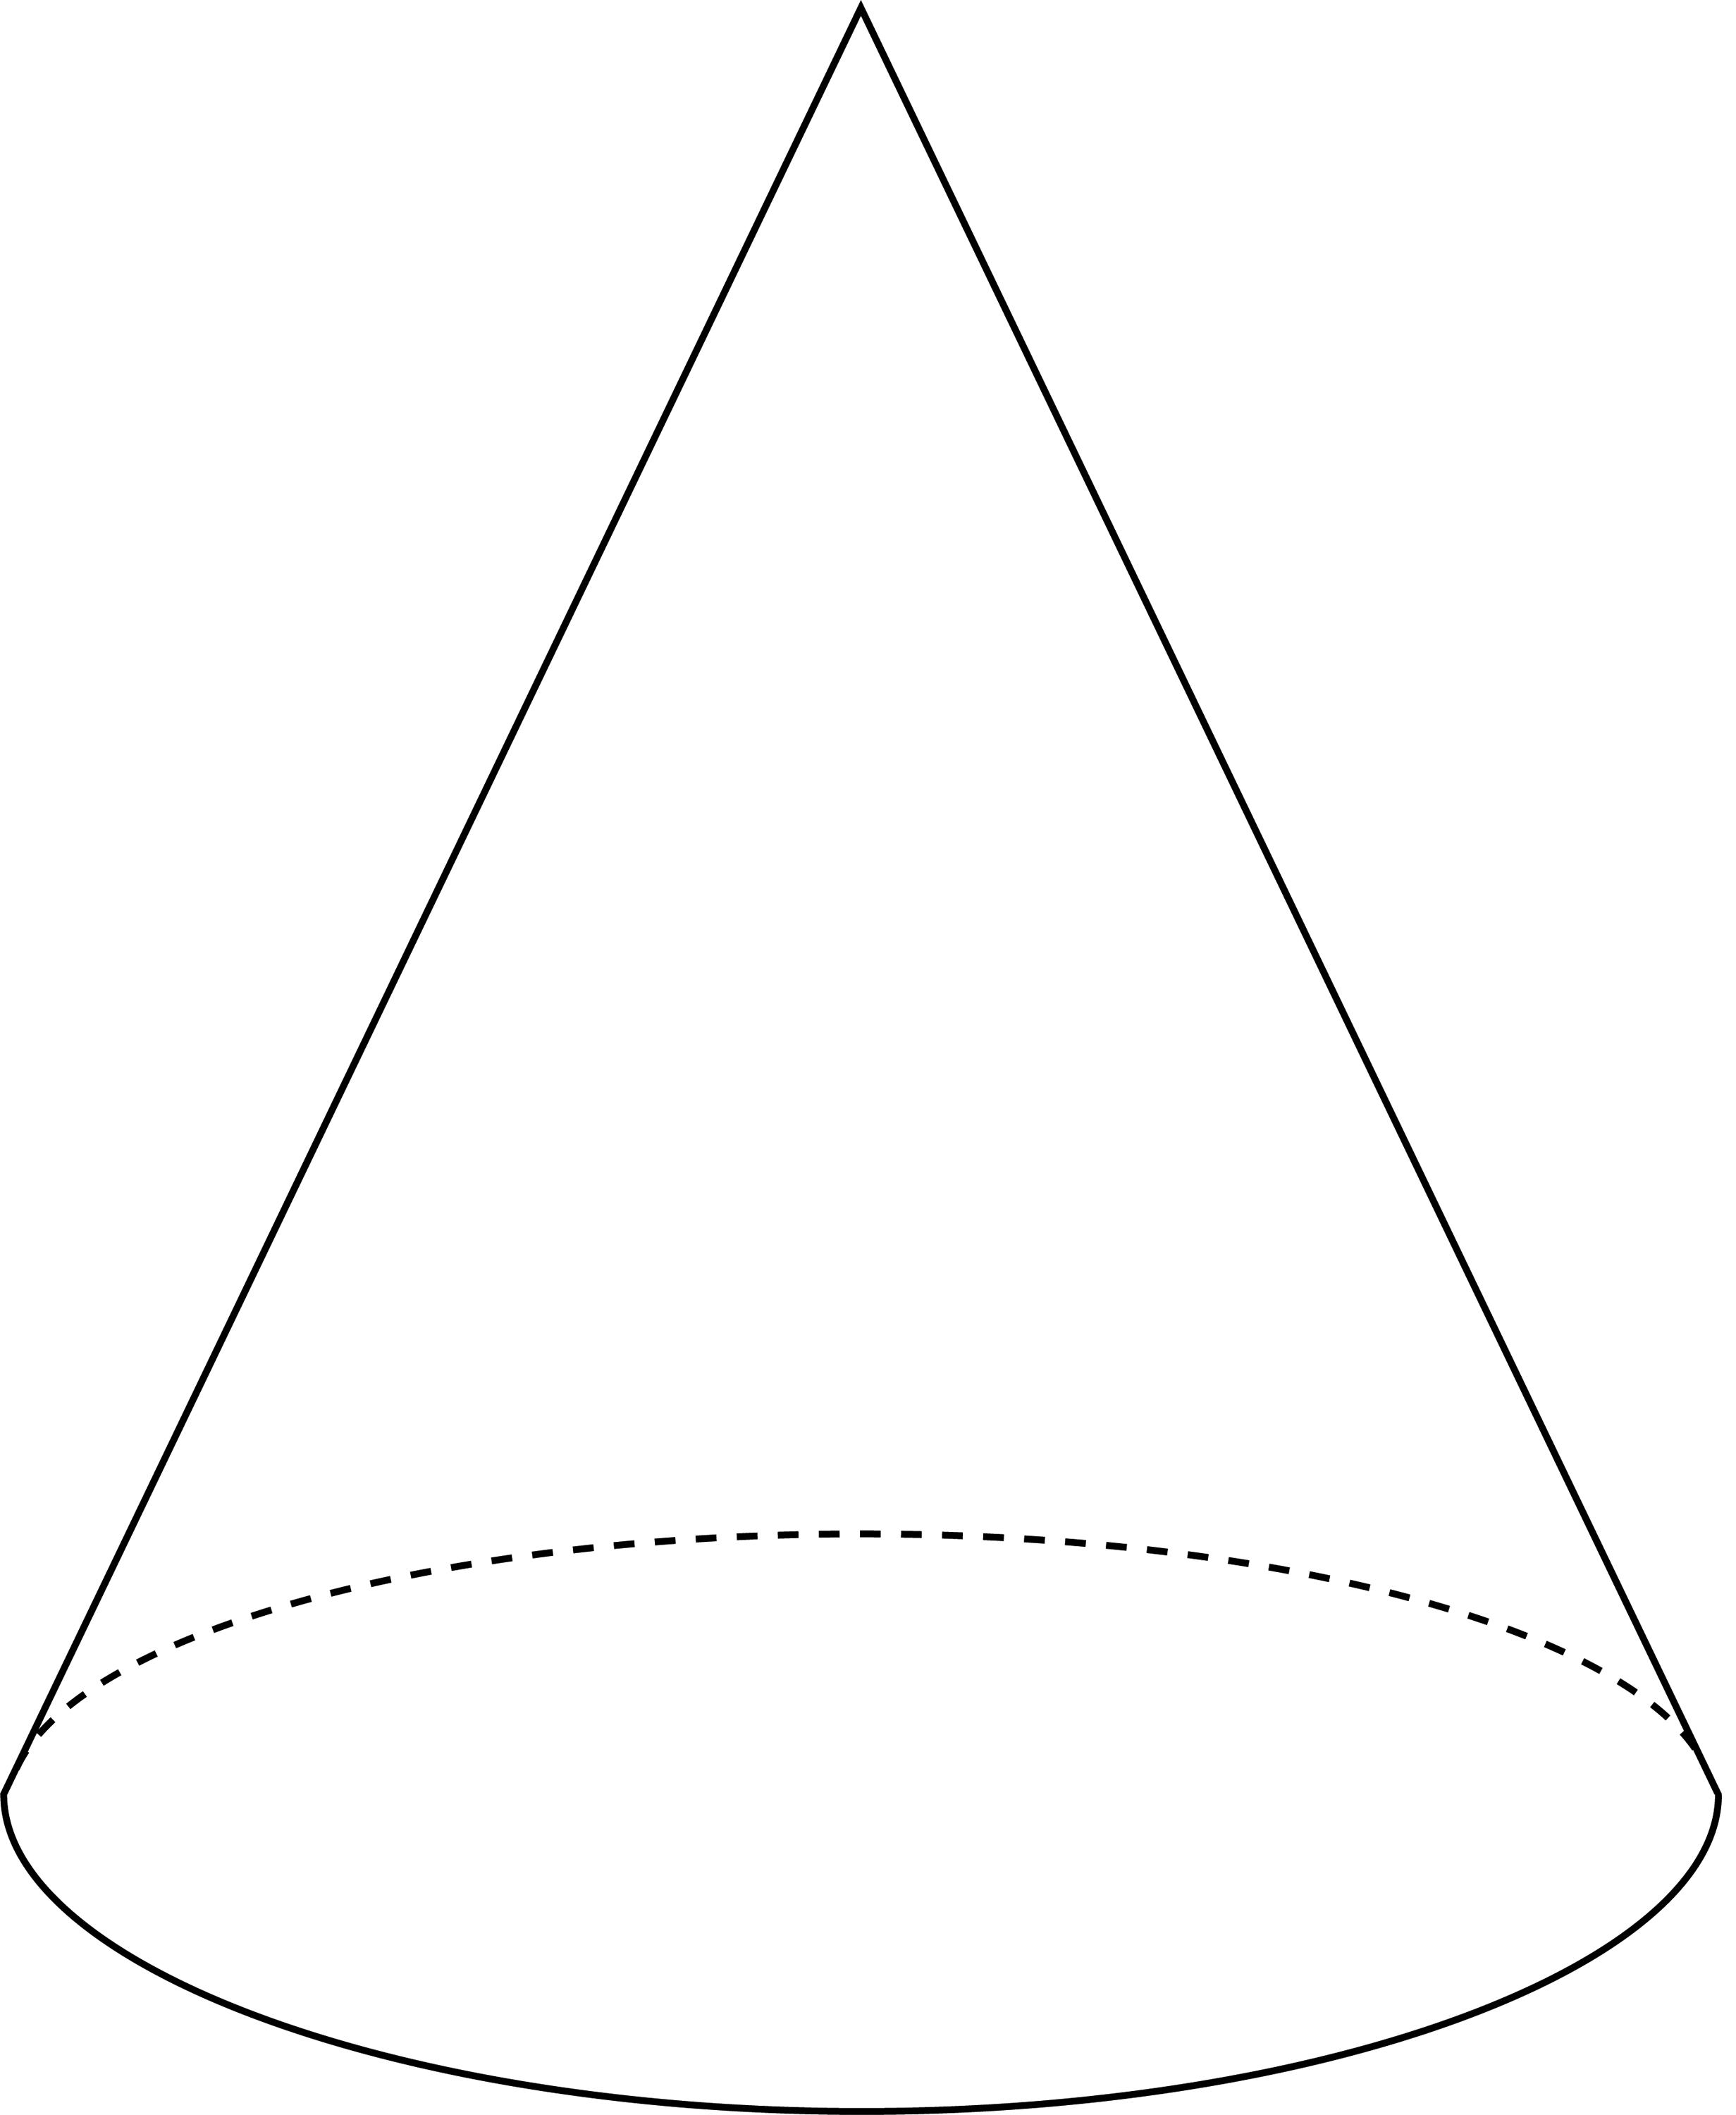
A Right Circular Cone is generated by rotating a right-triangular region around one of its perpendicular legs.
- The leg used as the axis becomes the height.
- The other perpendicular leg generates the base radius.
- The hypotenuse generates the lateral surface.
- The right-angle vertex lies on the axis of revolution.
Geometric characteristics:
- One circular base.
- One vertex.
- One curved lateral surface.
- A circular cross-section at every level between the vertex and base.

Conical Frustum
# Source: AI Source: Provided by: [Data Path: Persons Table -> ID Column: 1, Name_En Column: Motasem Essam] -> From: [ChatGPT] on [7/25/2026]
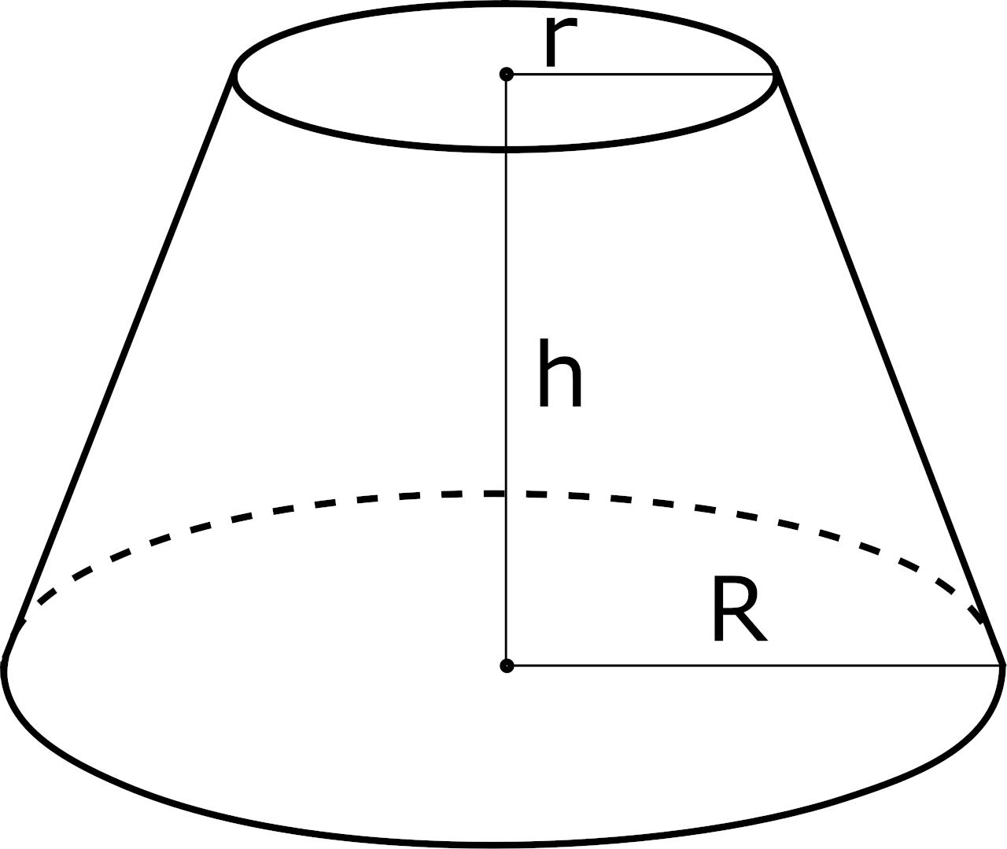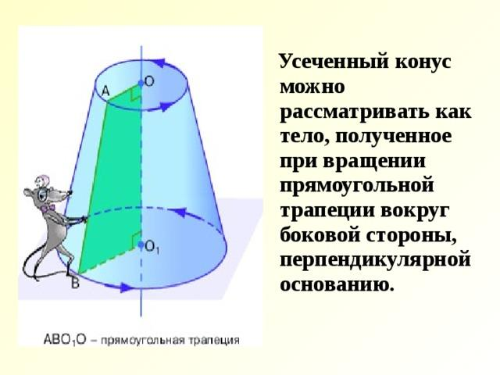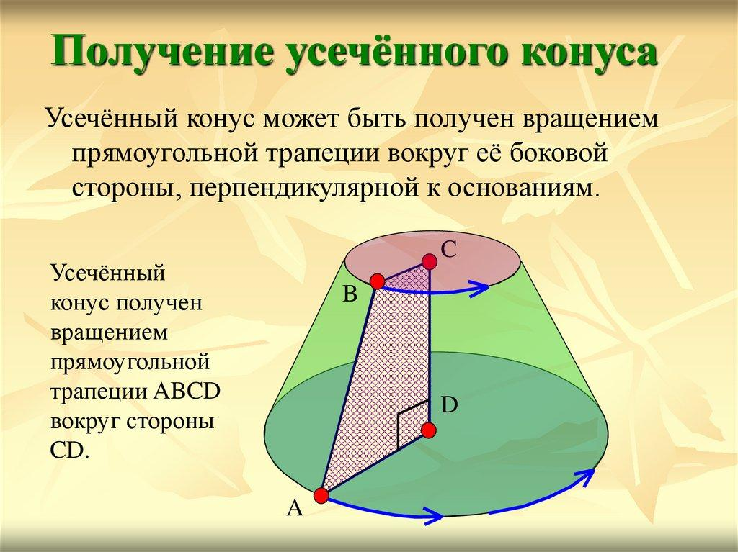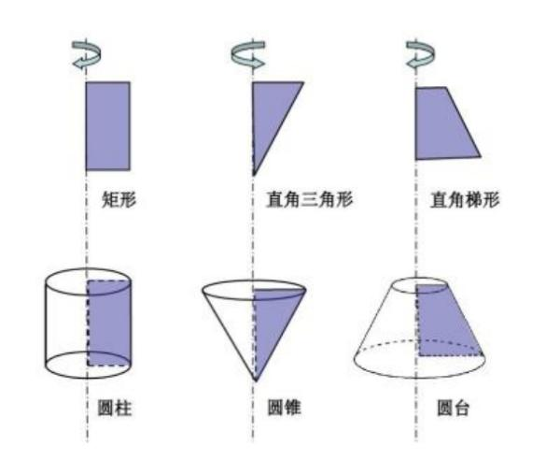
A Conical Frustum is generated by rotating a right-trapezoidal region around its perpendicular side, which acts as the axis of revolution.
It can also be obtained by cutting a right circular cone with a plane parallel to its base and removing the smaller cone above the cut.
Geometric characteristics:
- Two parallel circular bases.
- Two different base radii in the usual non-degenerate case.
- One truncated conical lateral surface.
- A height measured perpendicular to the base planes.
- A slant height measured along the lateral surface.

Double Cone (Bicone)
# Source: AI Source: Provided by: [Data Path: Persons Table -> ID Column: 1, Name_En Column: Motasem Essam] -> From: [ChatGPT] on [7/25/2026]
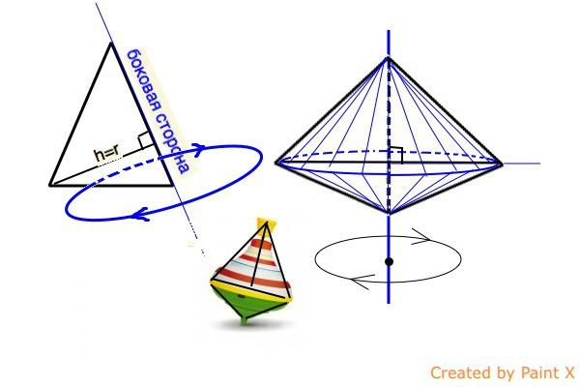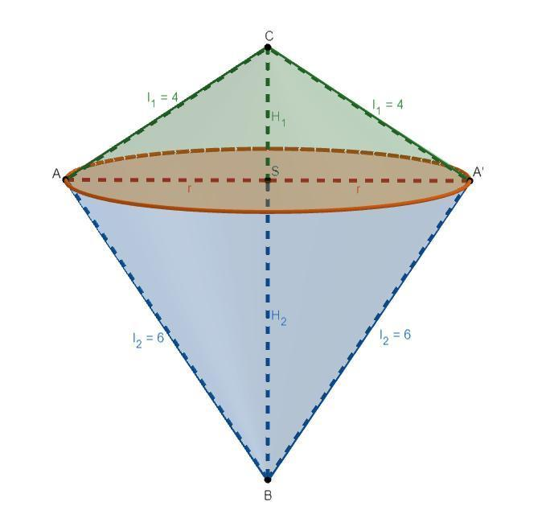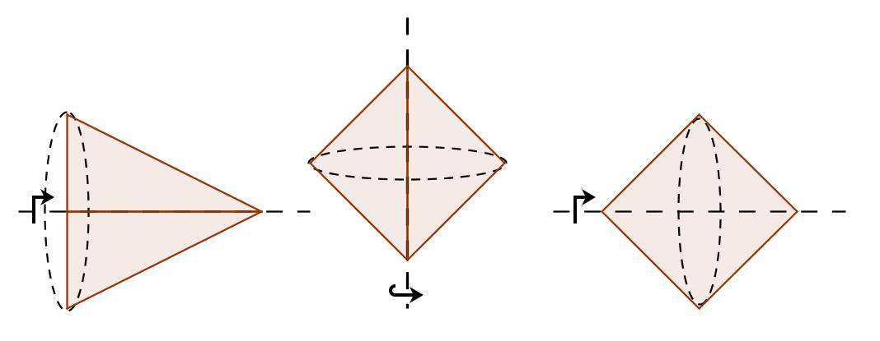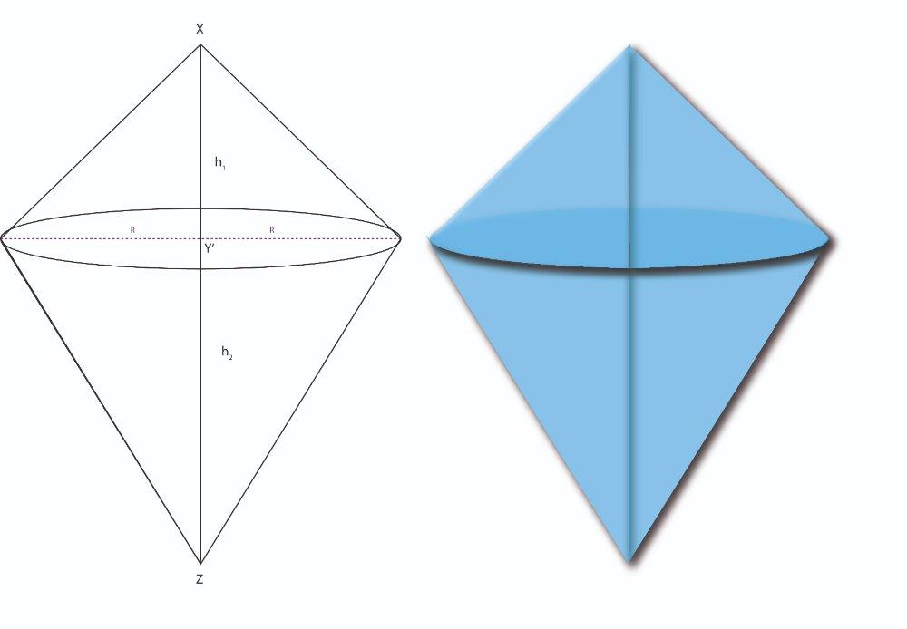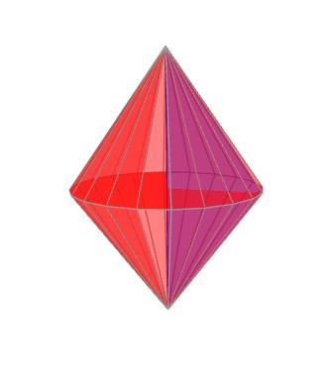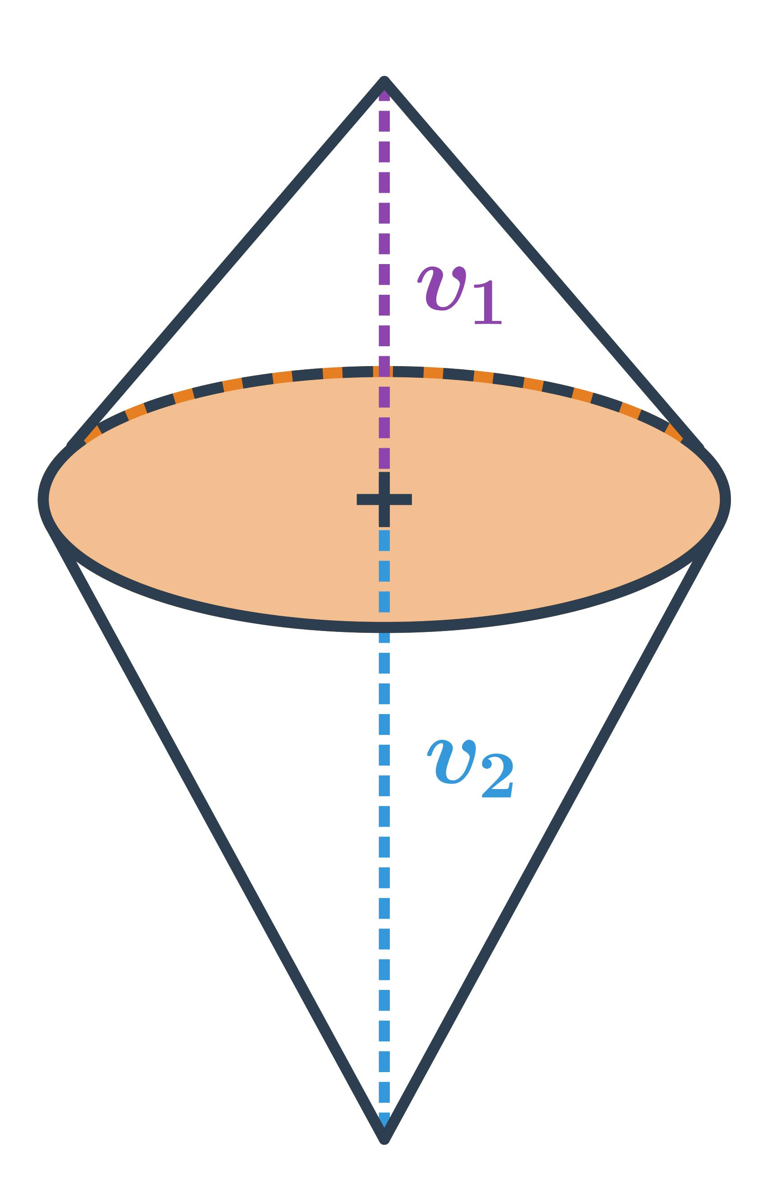
A Double Cone, also called a Bicone, is generated by rotating a triangular region around an axis passing through its interior, such as the altitude of an isosceles triangle.
The rotation creates two conical portions that meet at a common circular base.
Geometric characteristics:
- Two vertices.
- Two conical portions.
- One shared circular cross-section at the middle.
- A common axis passing through both vertices and the center of the shared base.
The two portions may have equal or different heights and radii, depending on the generating triangle and the position of the axis.

Hollow Conical Solid
# Source: AI Source: Provided by: [Data Path: Persons Table -> ID Column: 1, Name_En Column: Motasem Essam] -> From: [ChatGPT] on [7/25/2026]
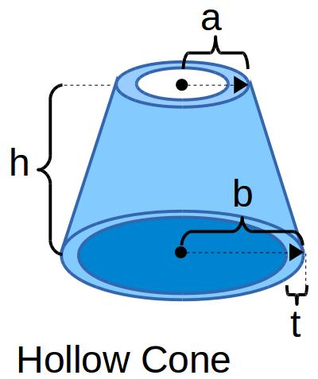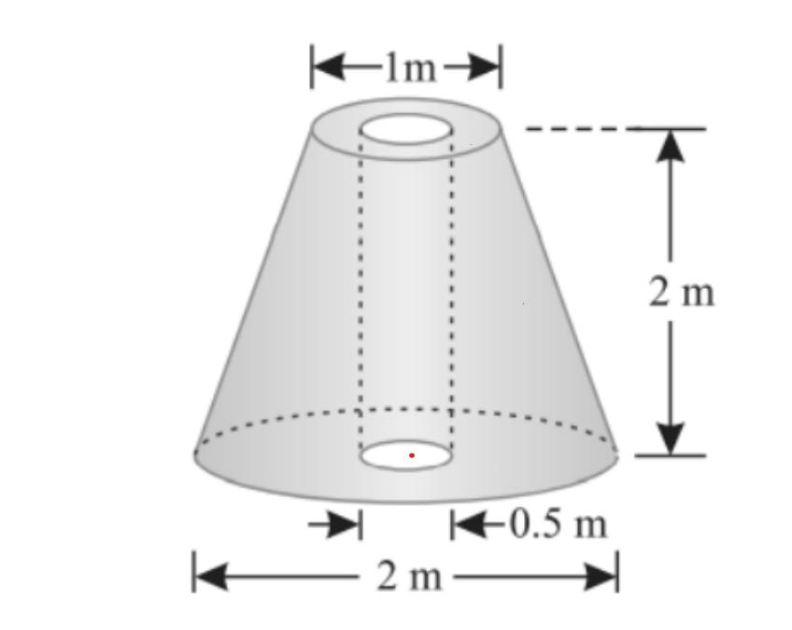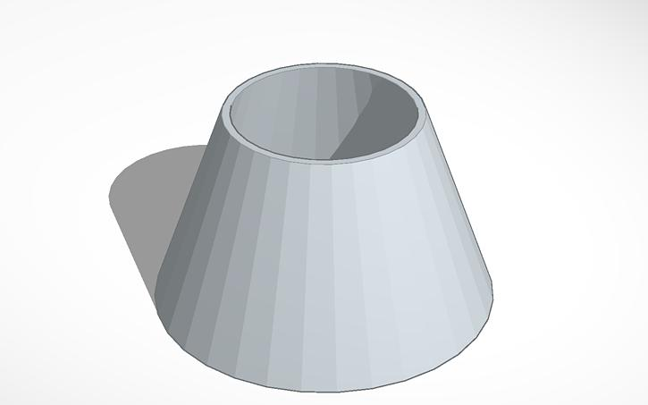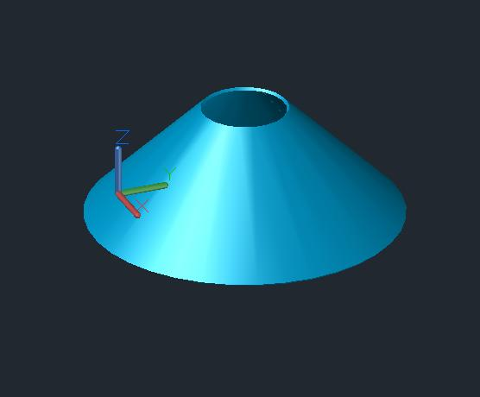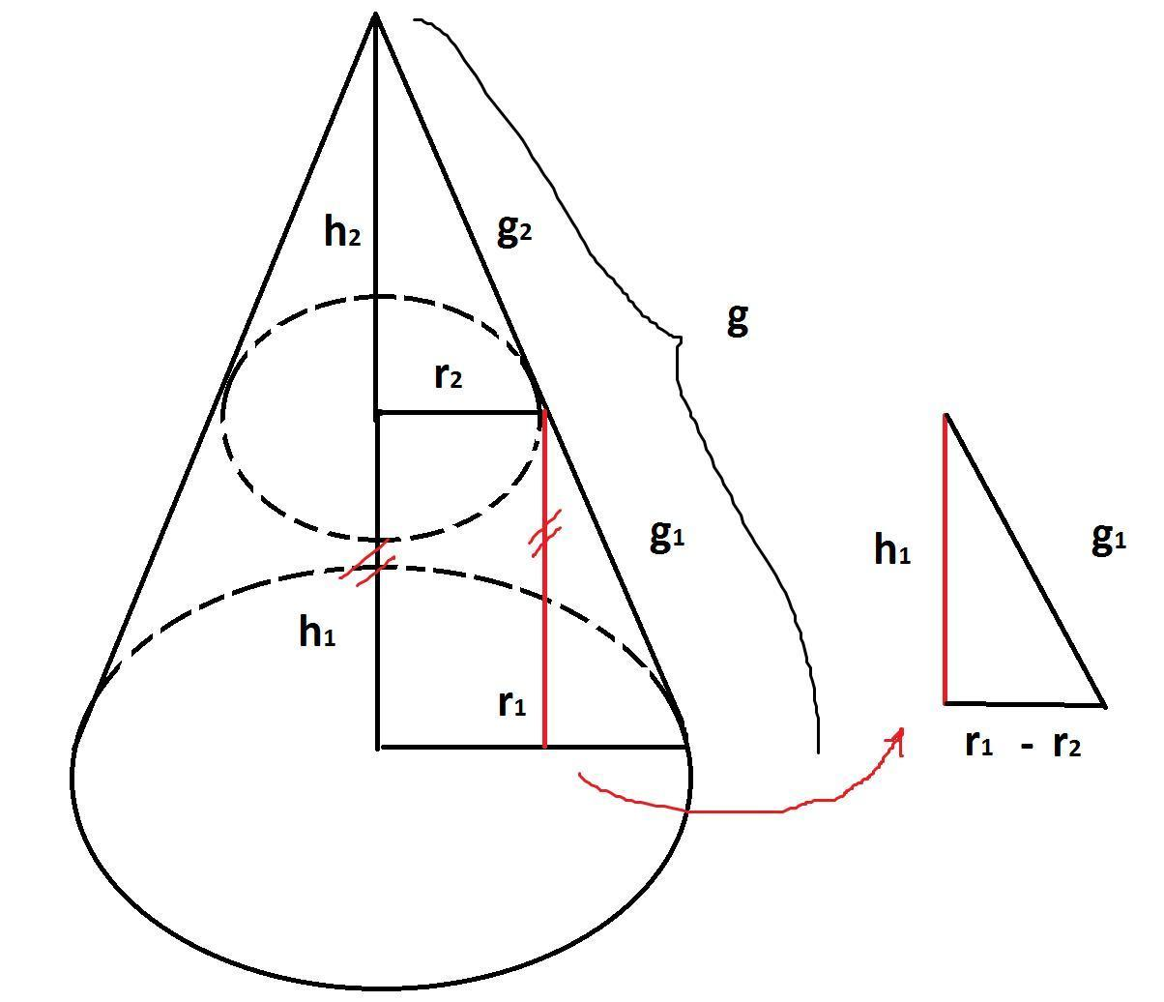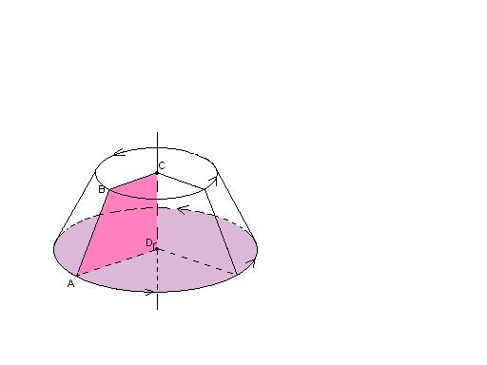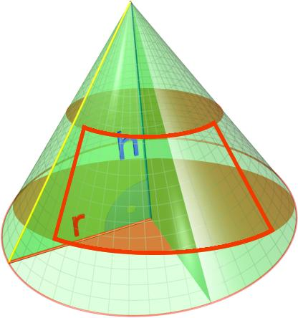
A Hollow Conical Solid is generated when a plane region that does not touch the axis of revolution is rotated around an external axis in its plane.
It produces a solid with an inner conical surface and an outer conical surface.
Examples include:
- Hollow conical frustums.
- Conical shells.
- Hollow tapered components.
Important distinction: A hollow conical solid has material occupying a region between inner and outer conical surfaces. A thin conical surface or shell with no thickness is not a filled solid.

Mathematical Representation

Right Circular Cone
# Source: AI Source: Provided by: [Data Path: Persons Table -> ID Column: 1, Name_En Column: Motasem Essam] -> From: [ChatGPT] on [7/25/2026]
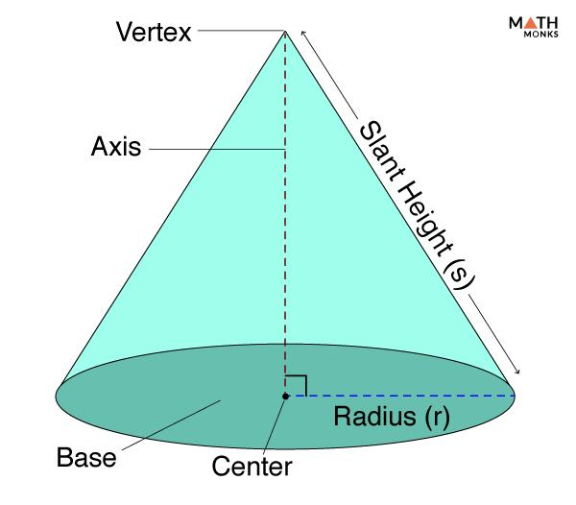
Let:
- $r$ = base radius.
- $h$ = perpendicular height.
- $l$ = slant height.
Slant Height
Using the Pythagorean theorem:
$$\boxed{l=\sqrt{r^{2}+h^{2}}}$$
Volume
Lateral Surface Area
$$A_{L}=πrl$$
Base Area
$$A_{B}=πr^{2}$$
Total Surface Area
$$\boxed{A_{T}=πr(l+r)}$$

Conical Frustum
# Source: AI Source: Provided by: [Data Path: Persons Table -> ID Column: 1, Name_En Column: Motasem Essam] -> From: [ChatGPT] on [7/25/2026]
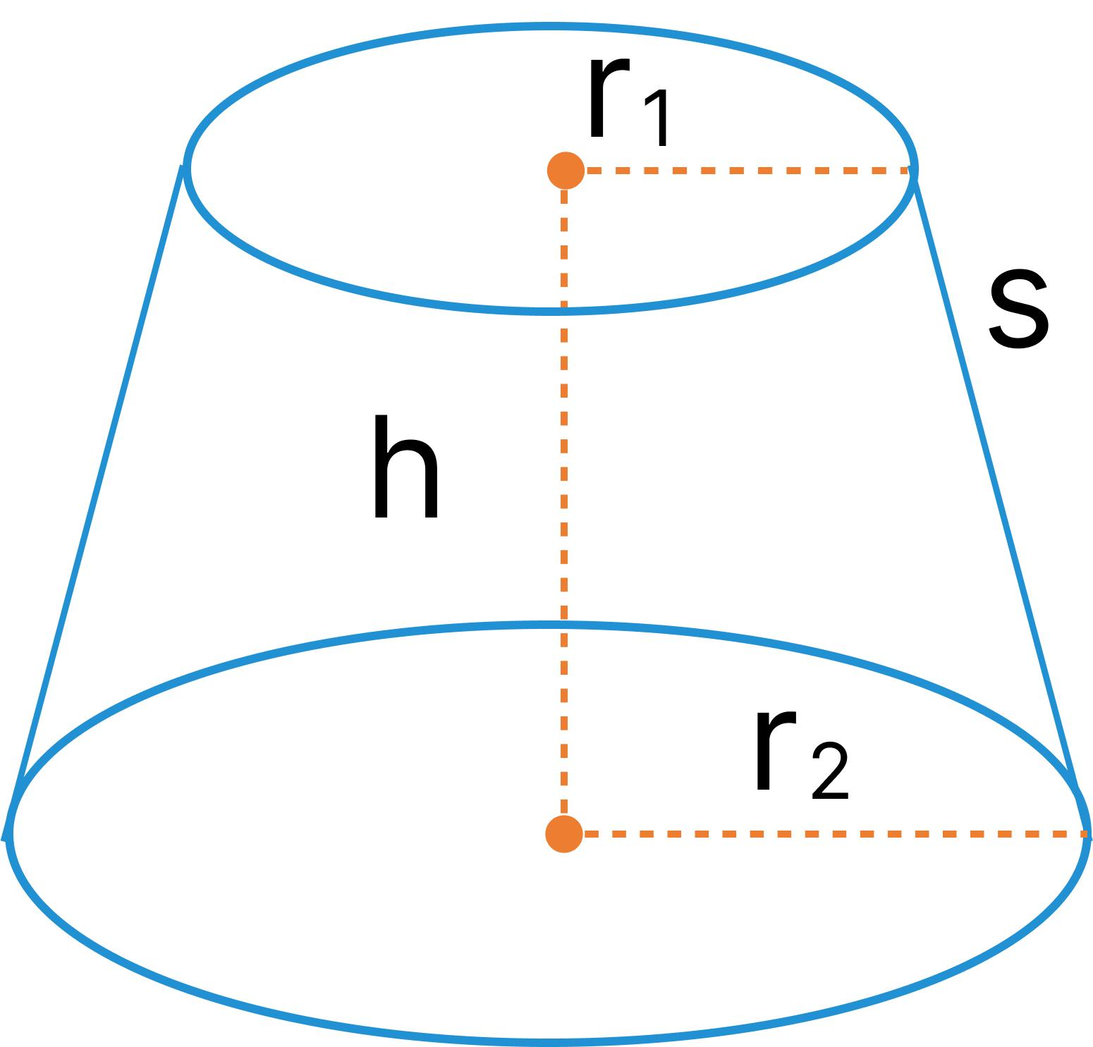
Let:
- $R$ = larger base radius.
- $r$ = smaller base radius.
- $h$ = perpendicular height.
- $l$ = slant height.
Slant Height
$$\boxed{l=\sqrt{h^{2}+(R−r)^{2}}}$$
Volume
$$\boxed{V=\frac{πh}{3}(R^{2}+r^{2}+Rr)}$$
Lateral Surface Area
$$A_{L}=π(R+r)l$$
Total Surface Area
$$\boxed{A_{T}=π(R+r)l+πR^{2}+πr^{2}}$$

Double Cone
# Source: AI Source: Provided by: [Data Path: Persons Table -> ID Column: 1, Name_En Column: Motasem Essam] -> From: [ChatGPT] on [7/25/2026]
A double cone consists of two cones sharing a common circular base.
Let:
- $r$ = radius of the shared base.
- $h_{1}$ = height of the first cone.
- $h_{2}$ = height of the second cone.
- $l_{1},l_{2}$ = their respective slant heights.
Total Volume
$$V=V_{1}+V_{2}$$
$$\boxed{V=\frac{1}{3}πr^{2}(h_{1}+h_{2})}$$
Combined Lateral Surface Area
$$\boxed{A_{L}=π{rl}_{1}+π{rl}_{2}}$$
The shared circular base is internal to the combined solid, so it is not included in its external surface area.

Hollow Conical Frustum
# Source: AI Source: Provided by: [Data Path: Persons Table -> ID Column: 1, Name_En Column: Motasem Essam] -> From: [ChatGPT] on [7/25/2026]
Let:
- $R_{o}$ = outer lower radius.
- $r_{o}$ = outer upper radius.
- $R_{i}$ = inner lower radius.
- $r_{i}$ = inner upper radius.
- $h$ = perpendicular height.
The volume of material is the difference between the outer and inner frustums:
$$\boxed{V=\frac{πh}{3}\left[(R_{o}^{2}+R_{o}r_{o}+r_{o}^{2})−(R_{i}^{2}+R_{i}r_{i}+r_{i}^{2})\right]}$$
This formula assumes the inner and outer frustums have the same height and parallel end planes.

Mathematical Properties
# Source: AI Source: Provided by: [Data Path: Persons Table -> ID Column: 1, Name_En Column: Motasem Essam] -> From: [ChatGPT] on [7/25/2026]
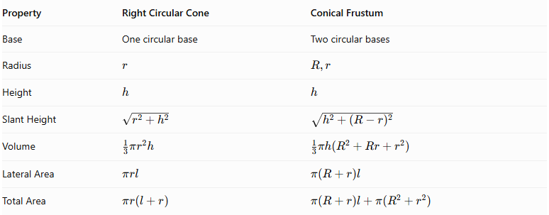
Property | Right Circular Cone | Conical Frustum
Base | One circular base | Two circular bases
Radius | $$r$$ | $$R,r$$
Height | $$h$$ | $$h$$
Slant Height | $$\sqrt{r^{2}+h^{2}}$$ | $$\sqrt{h^{2}+(R−r)^{2}}$$
Volume | $$\frac{1}{3}πr^{2}h$$ | $$\frac{1}{3}πh(R^{2}+Rr+r^{2})$$
Lateral Area | $πrl$ | $π(R+r)l$
Total Area | $$πr(l+r)$$ | $$π(R+r)l+π(R^{2}+r^{2})$$

Cross-Sectional Properties
# Source: AI Source: Provided by: [Data Path: Persons Table -> ID Column: 1, Name_En Column: Motasem Essam] -> From: [ChatGPT] on [7/25/2026]
For a right circular cone, a plane perpendicular to the axis produces a circular cross-section.
If $x$ is the distance measured from the vertex along the axis, the cross-sectional radius is:
$$ρ(x)=\frac{r}{h}x$$
The cross-sectional area is:
$$A(x)=π{\left(\frac{r}{h}x\right)}^{2}$$
This shows that the cross-sectional radius increases linearly from the vertex toward the base.
For a conical frustum, the radius changes linearly between the two base radii.
$$ρ(x)=r+\frac{R−r}{h}x$$
Here, $x=0$ is at the smaller base and $x=h$ is at the larger base.

Classification According to Geometric Features
# Source: AI Source: Provided by: [Data Path: Persons Table -> ID Column: 1, Name_En Column: Motasem Essam] -> From: [ChatGPT] on [7/25/2026]
Conical solids can also be distinguished by their structural properties:
- Complete Conical Solid: A cone extending from its circular base to its vertex.
- Truncated Conical Solid: A cone whose vertex portion has been removed by a plane parallel to its base, producing a frustum.
- Double Conical Solid: Two conical portions joined at a common base.
- Hollow Conical Solid: A conical solid containing an internal opening.
- Composite Conical Solid: A solid formed by combining two or more conical components, possibly with other geometric solids.

Applications
# Source: AI Source: Provided by: [Data Path: Persons Table -> ID Column: 1, Name_En Column: Motasem Essam] -> From: [ChatGPT] on [7/25/2026]
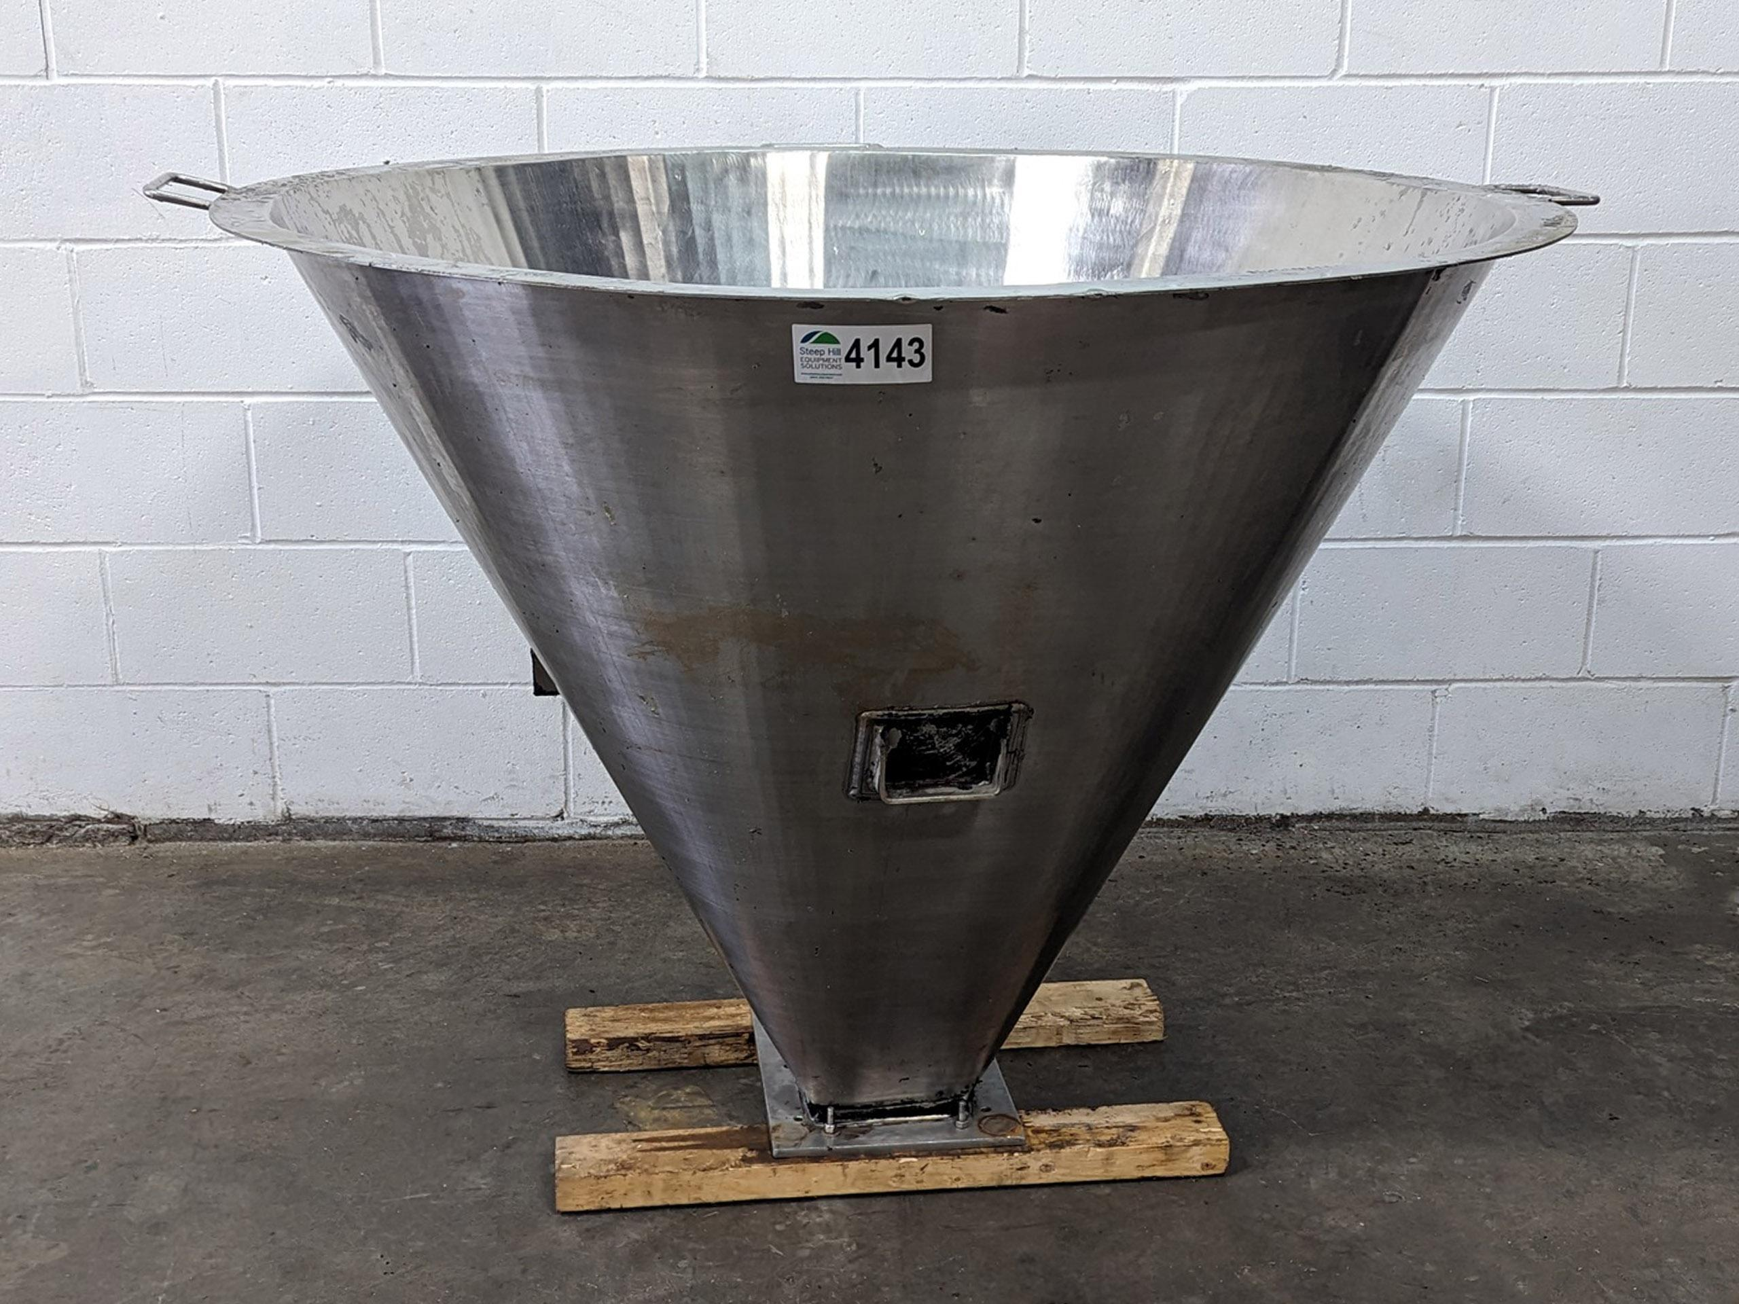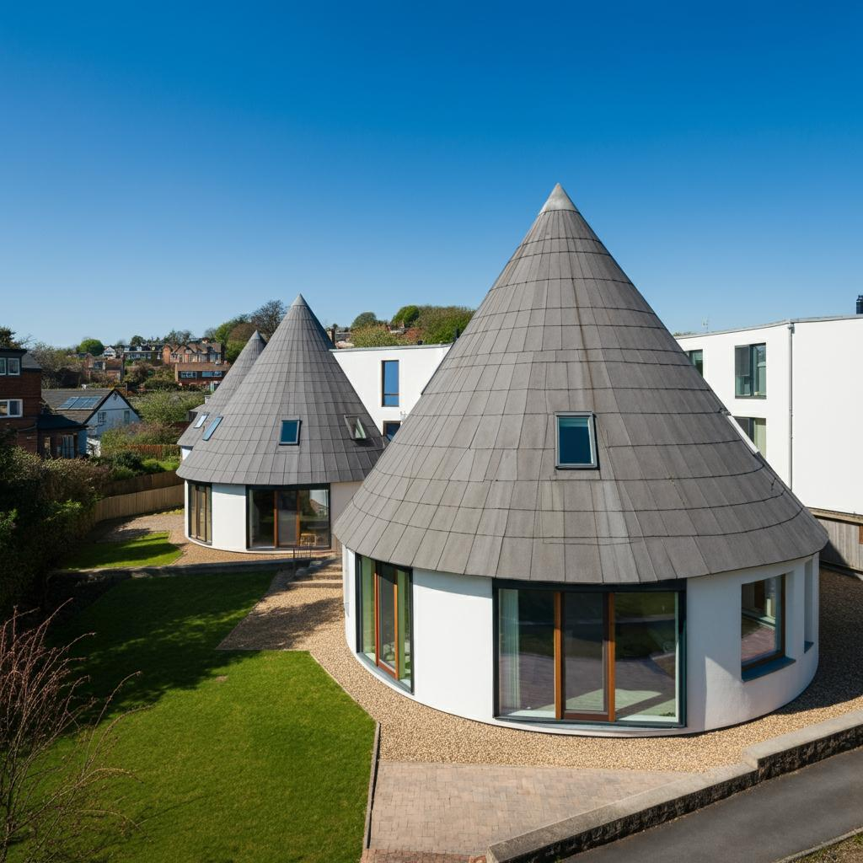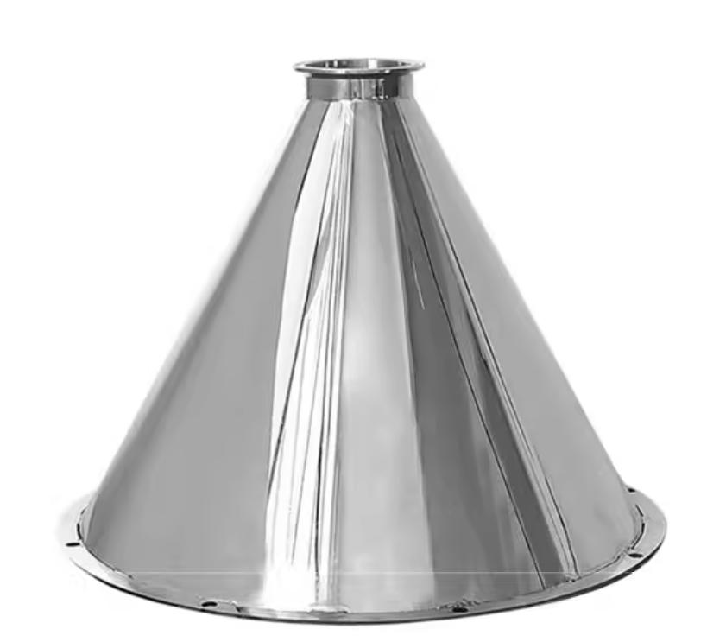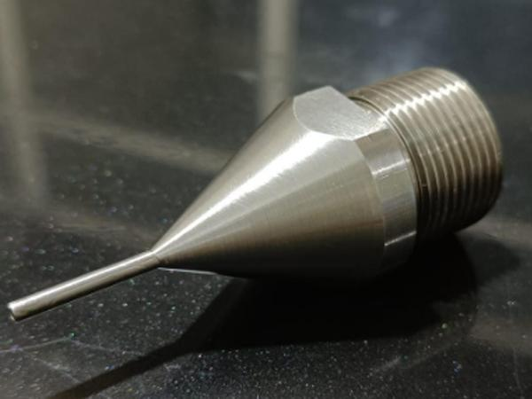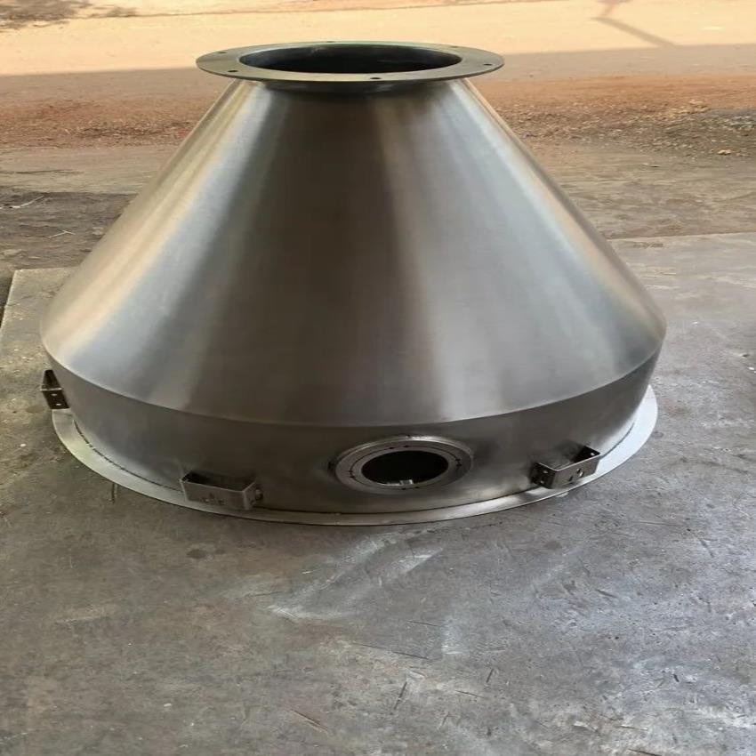
Conical solids of revolution are used in:
- Mechanical Engineering: Conical gears, tapered components, and machine parts.
- Industrial Manufacturing: Funnels, hoppers, nozzles, and conical containers.
- Architecture: Conical roofs, towers, and decorative structures.
- Aerospace Engineering: Nose cones and aerodynamic components.
- Construction: Concrete cones, tapered supports, and structural transitions.
- Fluid Systems: Conical reducers, flow-control components, and discharge hoppers.

Comparison Between Cylindrical and Conical Solids of Revolution
# Source: AI Source: Provided by: [Data Path: Persons Table -> ID Column: 1, Name_En Column: Motasem Essam] -> From: [ChatGPT] on [7/25/2026]
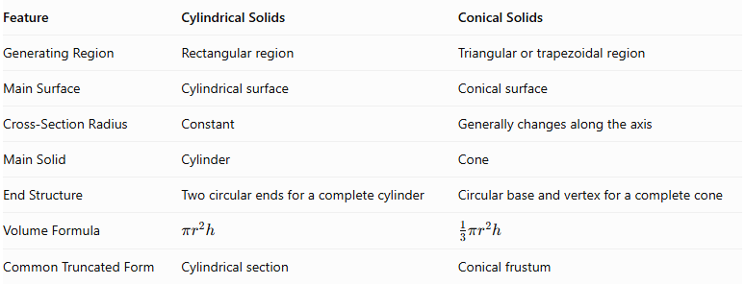
Feature | Cylindrical Solids | Conical Solids
Generating Region | Rectangular region | Triangular or trapezoidal region
Main Surface | Cylindrical surface | Conical surface
Cross-Section Radius | Constant | Generally changes along the axis
Main Solid | Cylinder | Cone
End Structure | Two circular ends for a complete cylinder | Circular base and vertex for a complete cone
Volume Formula | $$πr^{2}h$$ | $$\frac{1}{3}πr^{2}h$$
Common Truncated Form | Cylindrical section | Conical frustum

Main Classification
# Source: AI Source: Provided by: [Data Path: Persons Table -> ID Column: 1, Name_En Column: Motasem Essam] -> From: [ChatGPT] on [7/25/2026]
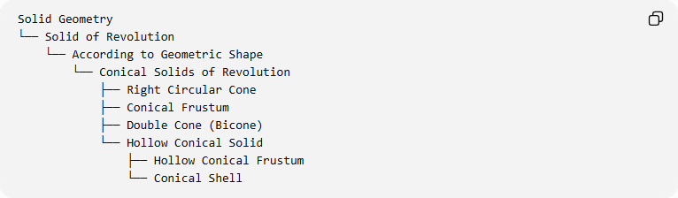
Solid Geometry
└── Solid of Revolution
└── According to Geometric Shape
└── Conical Solids of Revolution
├── Right Circular Cone
├── Conical Frustum
├── Double Cone (Bicone)
└── Hollow Conical Solid
├── Hollow Conical Frustum
└── Conical Shell

Key Points
# Source: AI Source: Provided by: [Data Path: Persons Table -> ID Column: 1, Name_En Column: Motasem Essam] -> From: [ChatGPT] on [7/25/2026]
- Conical solids of revolution are generated by rotating suitable triangular or trapezoidal regions.
- A right triangle rotated around one of its perpendicular legs generates a right circular cone.
- A right trapezoid rotated around its perpendicular leg generates a conical frustum.
- An isosceles triangle rotated around its altitude generates a double cone.
- A region rotated around an external axis can generate a hollow conical solid.
- The radius of a right circular cone changes linearly along its axis.
- A conical frustum has two parallel circular bases.
- The slant height, perpendicular height, and base radius are different geometric measurements.

Conclusion
# Source: AI Source: Provided by: [Data Path: Persons Table -> ID Column: 1, Name_En Column: Motasem Essam] -> From: [ChatGPT] on [7/25/2026]
Conical Solids of Revolution are an important category of rotationally generated solids characterized by their tapering geometry and circular cross-sections. Their principal forms include right circular cones, conical frustums, double cones, and hollow conical solids. They are widely used in mathematical geometry, engineering, architecture, and industrial design.

Sources
# Source: AI Source: Provided by: [Data Path: Persons Table -> ID Column: 1, Name_En Column: Motasem Essam] -> From: [ChatGPT] on [7/25/2026]
- Project Gutenberg – Solid Geometry: Generating a Right Circular Cone
- In2Infinity – Cones, Conical Surfaces, and Frustums
- OpenStax – Determining Volumes by Slicing
- Australian Mathematical Sciences Institute – Cones, Pyramids and Spheres

